|  |  |  |  |  |  |  |  |  |  |  |  |  |
| --- | --- | --- | --- | --- | --- | --- | --- | --- | --- | --- | --- | --- |
| Sunday | Monday | | Tuesday | | Wednesday | | Thursday | | Friday | | Saturday | |
| 30 | | 1  **C** | | 2  **L** | | 3  **O** | | 4  **S** | | 5  **E** | | 6  **D** |
| 7  **Theme:** STEM  **Letter: N**  **Number: 5** | | 8  What STEM is | | 9  Science | | 10  Technology | | 11  Engineering | | 12  Mathematics | | 13 |
| 14  **Theme:** Summer Habitats  **Letter: O**  **Number: 6** | | 15  Bird & Owl Habitats | | 16  Squirrel & Chipmunk Habitats | | 17  Where Bears Live in Summer | | 18  Fox Habitats | | 19  Insect Habitats | | 20 |
| 21  **Theme:**  Performing Arts  **Letter: P**  **Number: 7** | | 22  Types of Performing Arts | | 23  Performative Dance | | 24  History of Dance | | 25  Evolution of Theater | | 26  Famous Moments in Theater | | 27 |
| 28  **Theme:** Summer Olympics  **Letter: Q**  **Number: 8** | | 29  What are the Olympics? | | 30  Athletes | | 31  Qualifying for the Olympics | | 1  Olympic Sports | | 2  Opening and Closing Ceremonies | |  |

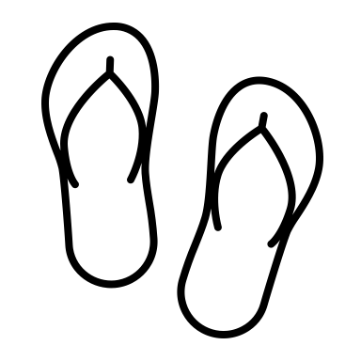 July 2024 Pre-Kindergarten